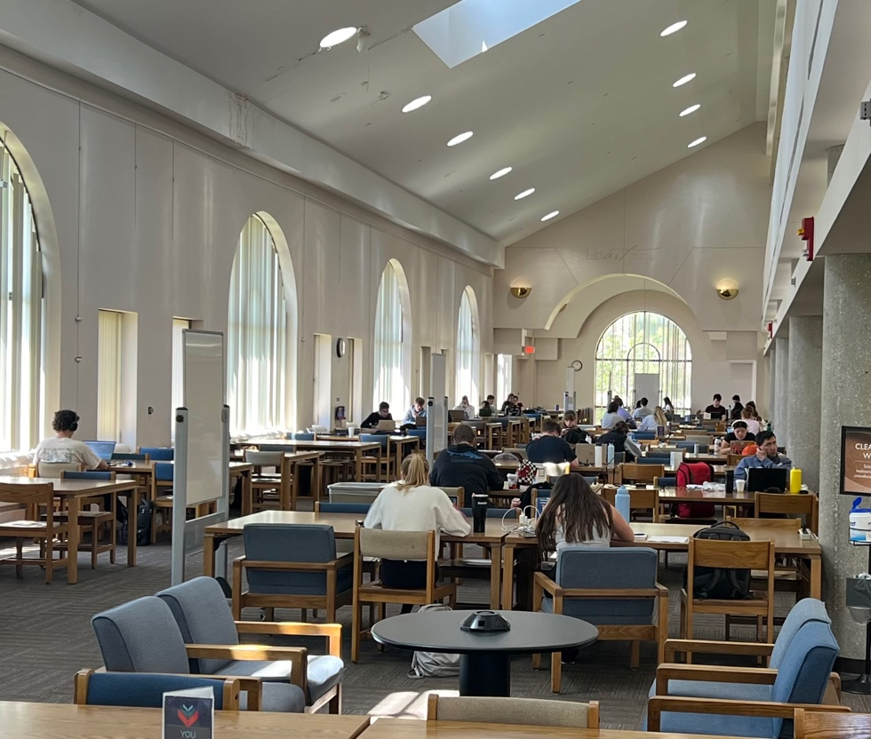
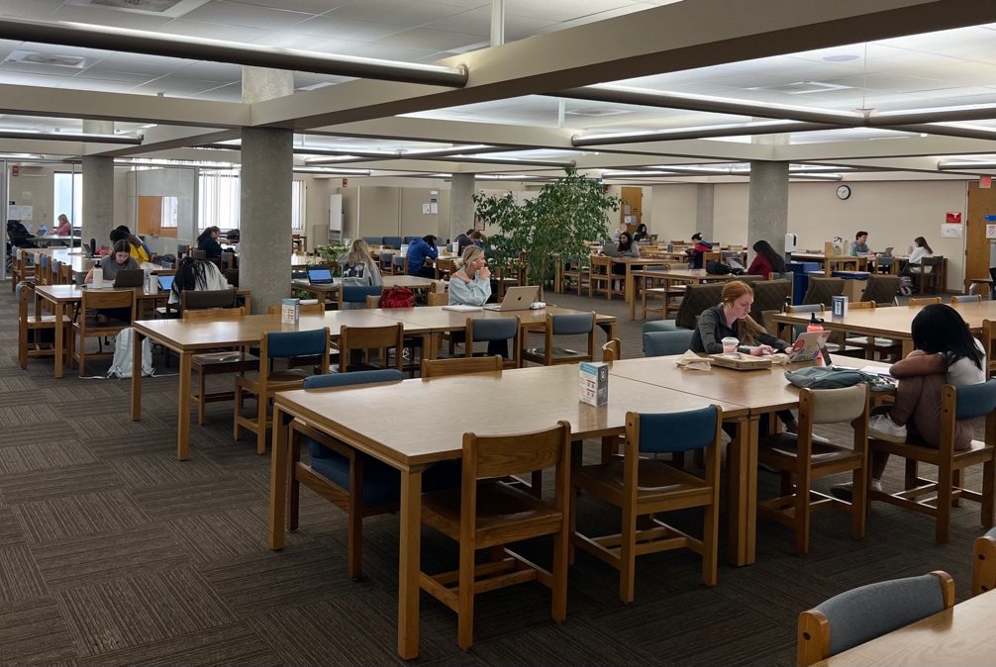
Anschutz Library During Finals Week

Anschutz Library – 1st Floor

Anschutz Library – 2nd Floor

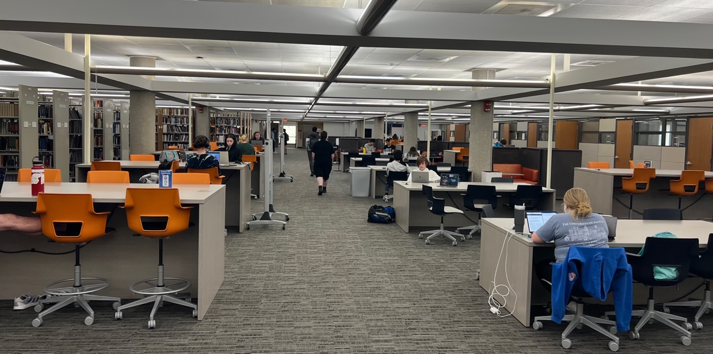

Anschutz Library –3rd Floor

